1. **History:**

* spring source ------> covalent -----------> VMware

1. **Spring** :

* Lightweight loosely coupled, highly integrated framework used to design web application

1. **Advantage:**

* Layered Architecture
* Dependency Injection
* Enable Polo Programming
* Open Source
* Light Weight
* Loosely Coupled
* Easy to test

1. **Features:**

* Light Weight
* IOC
* AOP
* Container
* MVC Framework
* Transaction Management
* JDBC Exception Handling

1. **Modules**:

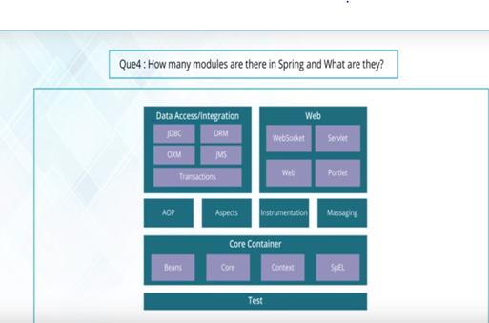

1. **Spring IOC:**

* user configure object in xml File
* spring container read this file
* construct the object

1. **Role Of IOC Container:**

* creating the instance
* configuring the instance
* assembling the dependencies

1. **Bean:**

An object from the backbone of your application managed by spring ioc container.

1. **Bean Factory And Application Context:**

* Bean factory is basic container is a collection of beans and instantiate the bean
* Bean Factory provide lazy initialization.
* In Bean Factory explicitly provide resource object.
* Bean Factory doesn't support annotation based di.
* Bean Factory doesn't support internalization.
* Application context is advanced container that extends bean factory and provide some extra features like spring aop.

### What is the difference between constructor injection and setter injection?

1. **Advantage Of IOC:**

* it minimizes the amount of code
* promote loose coupling
* provide lazy and eager service instantiation.

1. **How Configuration Meta Data is provided to Spring Container?**

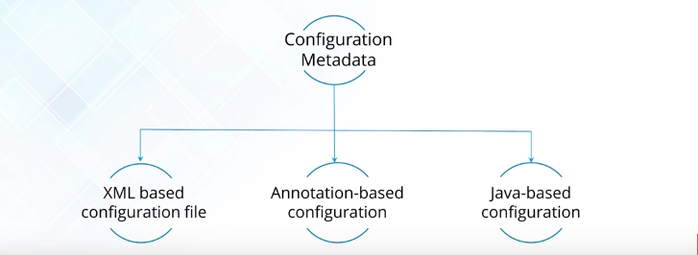

1. **Scopes:**

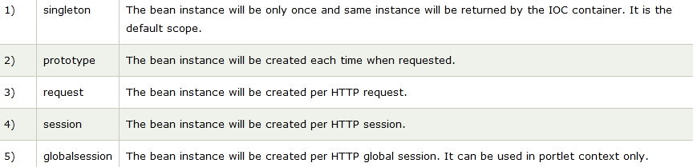

1. **Disadvantage of auto wiring:**

* overriding possibilities.
* confusing nature.
* complicated with primitive data types

1. **Annotation Wiring Enabled:**

<context:annotation-config></context:annotation-config>

1. **@Qualifier:**

It is used simultaneously with the @Autowired annotation to avoid confusion when multiple instances of a bean type are present.

1. **@Required:**

The @Required annotation is used on setter methods, and it indicates that the bean property that has this annotation must be populated at configuration time.

1. **@InitBinder:**

A method annotated with @InitBinder is used to customize a request parameter, URI template, and backing/command objects.

1. **Programmatic:**

* In Programmatic transaction management Transaction is managed with the help of programming.
* it is difficult to maintain.

1. **Declarative Transaction**

* Transaction is managed with the help of annotation.
* Transaction Management is separated from business logic

1. **What are classes for spring JDBC API?**

* JdbcTemplate
* SimpleJdbcTemplate
* NamedParameterJdbcTemplate
* SimpleJdbcInsert
* SimpleJdbcCall

1. **Spring AOP VS Aspect AOP**

* **Spring Aop:**
* it performs weaving at run time**.**
* it support method level point cut**.**
* **Aspect Aop:**
* it performs weaving at compile time.
* it support field level point cut.

1. **Proxy Object :**

* An object create after applying to advice is known as proxy object.

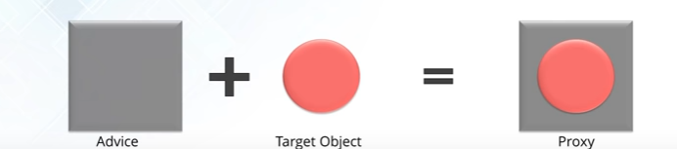

1. **Weaving:**

* when an aspect link with another application or the object to create an advised object.

1. **Dispatcher Servlet:** 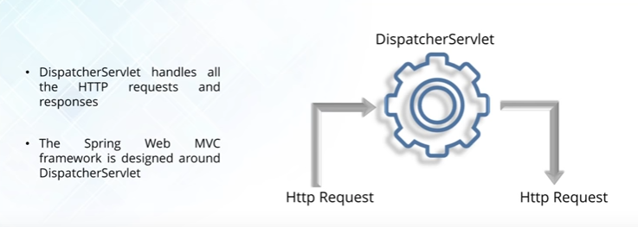
2. **Web ApplicationContext:**

* webApplicationContext is an extension of application context.
* ApplicationContext is a core container.
* webApplicationContext is container on webApp Layer.

1. **Controller:**

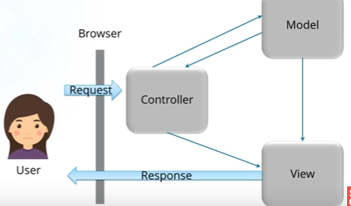

1. **Spring 4.0 new :**

* RestController
* Jcache
* ResponsBody
* ResponseEntity
* WebSocketBased Communication

1. **Spring Batch:**

* Restart ability
* Different Reader and Writers
* Chunk Processing.

1. **Bean Life Cycle**

* public void init()
* public void destroy()

1. Bean Instantiate
2. Bean Property Set
3. Init Method Called
4. The **PostConstruct** annotation is used on a method that needs to be executed after dependency injection is done to perform any initialization.
5. InitializingBean, it will run afterPropertiesSet() after all bean properties have been set.
6. **DisposableBean**, it will run destroy() after Spring container is released the bea\
7. Destroy Method invoked.